The only geocryology department among the World Universities, with about 30 academic staff members and over 60 undergraduate and graduate students. A Master Program in English on Geocryology started for Russian and foreign students in 2015.

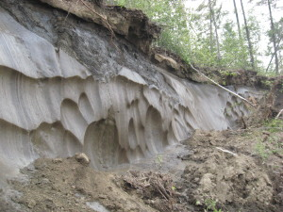

Students enjoy a lifestyle in Moscow. There hundreds of museums, theatres, concert halls and restaurants in the Russian capital. University campus is located in one the most beautiful areas, surrounded by parks. Friends and family are welcome at all times.

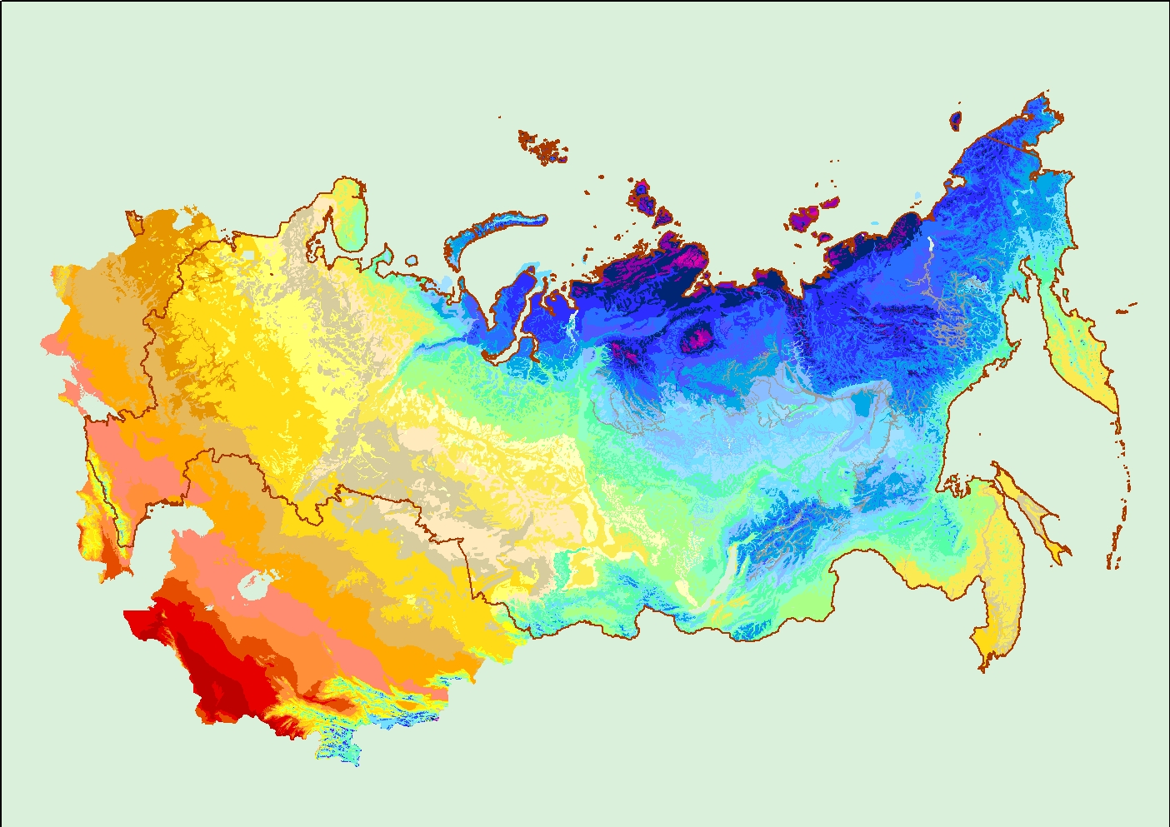

Address: Geocryology Department,
Faculty of Geology,
Lomonosov Moscow State University, GSP-1, Leninskie Gory, Moscow, 119991,
Russian Federation

Tel. +7 (495) 939-1728
+7 (495) 939-1281

E-mail: permafrost@geol.msu.ru

www.geocryology.com

Geocryology Department of Moscow State University

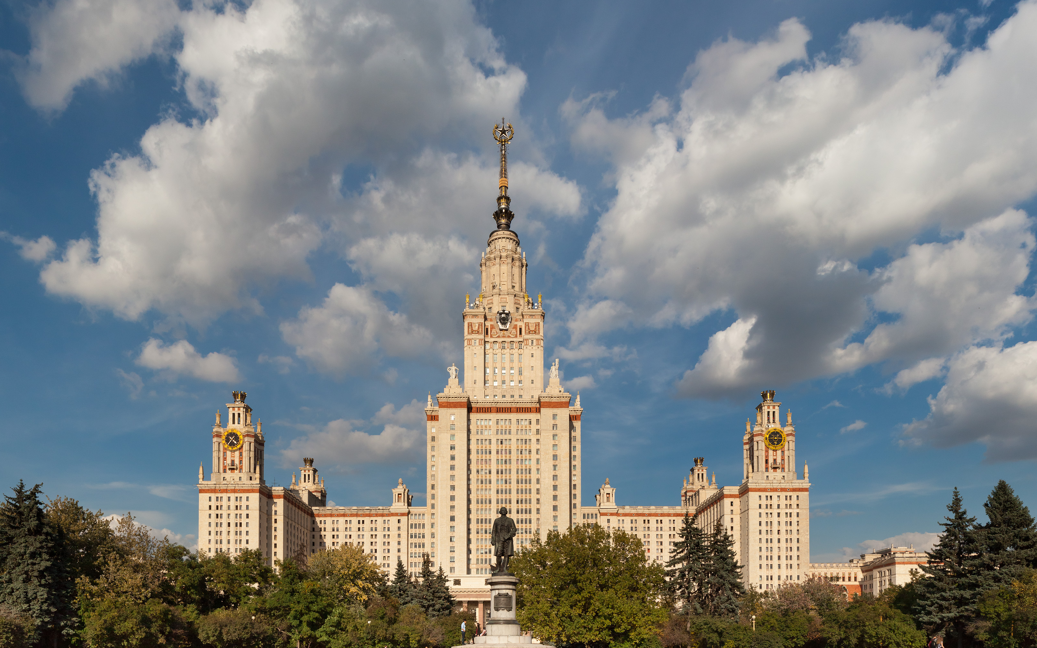

Russia has the largest territory of permafrost in the world and traditions to explore, work and survive there.

Courses
Permafrost Dynamics
The temperature mode of soil and dynamics of permafrost soils, cryogenic processes, and climate change influence on cryolithozone. The course defines a place and a role of permafrost in environment, gives knowledge of formation of seasonal frozen soils and permafrost. The discipline introduces students to permafrost landforms.

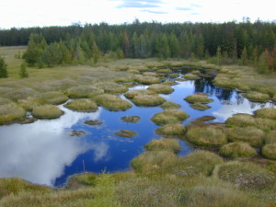

Frozen Soils Structure and Properties
Nature of frozen soils, their structure and properties. Frozen soils are considered as multi-phase, multi-component systems. Development of the physic-chemical and mechanical processes is discussed, as well as soil structure and properties transformation under freezing and thawing.

Methods of Permafrost Studies
The major tasks of the study are the skills of planning, organization and scientific support of the field permafrost survey and specialized observations, including data processing, maps drawing-up, description of cryogenic processes.

Permafrost Geotechnics
The engineering constructions and their interaction with the environment are discussed. Methods of the forecast of thermal and mechanical stability of engineering constructions on permafrost are studied. Buildings, pipelines, railways, airfield construction in the North are studied.

Permafrost of the World
The main task is to give to students an idea of permafrost distribution all around the world; to characterize the basic regularities of extent and formation of permafrost and seasonally frozen grounds together with the history of the environment.

Regional Geocryology of Russia
Permafrost conditions together with the climate, geological and tectonic structure and history.

Geocryology of Solar System’s Planets
Permafrost conditions and cryogenic processes, taking place on planets of Solar system. The major directions of course are Martian cryosphere and its cryogenic processes; methods of study of cryogenic processes on extraterrestrial planets.

Optional Courses
Pollution of Permafrost Soils
An overview of the problems, related to pollution of permafrost and influence of pollutants on frozen and freezing soils properties.

Soils Melioration in Cryolithozone
The methods of strengthening of the frozen soils are considered in this course.

Evolution of Cryosphere
The main objective is the history of the Earth cryosphere.

Chemical Migration in Permafrost
The behavior of salts and pollutants including heavy-metal ions, radioactive elements in freezing and frozen soils.

Gas and Gas Hydrates
Gas and gas hydrate content of permafrost and subpermafrost horizons are studied in this course.

Geophysical Methods
The magnetic, electric, seismic, radioactive properties of frozen sediments are discussed in this lecture course.

Field Training
Field Training in Vorkuta
Construction on permafrost: major problems. Methods of field studies are studied. Students participate in drilling of frozen grounds and equipment installation. Geophysics on permafrost are studied.

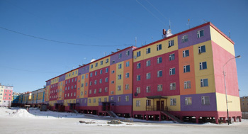

Coop Field Training

